Project Synopsis

on

**Chatbot to known Individual Prakriti (Phenotype)**

Submitted as a part of course curriculum for

**Bachelor of Technology**

in

**Computer Science**



**Submitted by**

Unnati Mittal (2300290129014)

Kanchan (2200290120088)

**Under the Supervision of**

Ms. Akanksha

Assistant Professor

**KIET Group of Institutions, Ghaziabad**

**Department of Computer Science**

**Dr. A.P.J. Abdul Kalam Technical University**

**2024-2025**

**ACKNOWLEDGEMENT**

It gives us a great sense of pleasure to present the synopsis of the B.Tech Mini Project undertaken during B.Tech. Third Year. We owe a special debt of gratitude to Ms. Akanksha (Assistant Professor), Department of Computer Science, KIET Group of Institutions, Delhi- NCR, Ghaziabad, for her constant support and guidance throughout the course of our work. Her sincerity, thoroughness and perseverance have been a constant source of inspiration for us. It is only her cognizant efforts that our endeavours have seen the light of the day.

We also take the opportunity to acknowledge the contribution of Dr. Ajay Kumar Shrivastava, Dean of the Department of Computer Science, KIET Group of Institutions, Delhi- NCR, Ghaziabad, for his full support and assistance during the development of the project. We also do not like to miss the opportunity to acknowledge the contribution of all the faculty members of the department for their kind assistance and cooperation during the development of our project.

Last but not the least, we acknowledge our friends for their contribution to the completion of the project.

Signature: Guide Name & Signature

Prof. Akanksha

Student’s Name: Unnati Mittal

Roll No: 2300290129014

Student’s Name: Kanchan

Roll No: 2200290120088 Signature

Project coordinator

Prof. Vinay Pratap Singh

**ABSTRACT**

The "VedaBuddy" application is a pioneering tool that aims to determine an individual's Ayurvedic Prakriti (phenotype) based on user input, offering personalized recommendations for health, lifestyle, and dietary adjustments. Rooted in the ancient wisdom of Ayurveda, which recognizes Vata, Pitta, and Kapha as the primary Dosha types influencing one's Prakriti, this application serves as a bridge between traditional knowledge and modern technology.

The user interface of VedaBuddy is designed to be intuitive and user-friendly, guiding users through a comprehensive questionnaire that considers various aspects of their physical attributes, behavioral tendencies, and other Ayurvedic indicators. This questionnaire is crucial for the "Prakriti Determination" module, which forms the core of the application.

The "Prakriti Determination" module utilizes sophisticated Ayurvedic algorithms to analyze user responses and identify the dominant Dosha(s) and overall Prakriti type accurately. This analysis forms the basis for the personalized recommendations provided by VedaBuddy. One of the key features of VedaBuddy is its ability to offer tailored advice for health, lifestyle, and dietary adjustments based on the user's Prakriti. These recommendations are derived from the rich repository of Ayurvedic knowledge and are aimed at promoting holistic well-being.

The modular codebase of VedaBuddy ensures scalability and maintainability, allowing for seamless updates and enhancements. This ensures that VedaBuddy remains a cutting-edge tool that continues to evolve with advancements in technology and Ayurvedic research. In conclusion, the "VedaBuddy" application represents a fusion of ancient wisdom and modern technology, empowering individuals to take charge of their health and well-being by providing personalized insights and recommendations based on the principles of Ayurveda.

**TABLE OF CONTENTS**

|  |  |
| --- | --- |
|  | Page No. |
| TITLE PAGE .................................................................................................................... | 1 |
| ACKNOWLEDGEMENT.................................................................................................. | 2 |
| ABSTRACT...................................................................................................................... | 3 |
| CHAPTER 1 INTRODUCTION | 5-9 |
| 1.1.  Ayurvedic Prakrati and Doshas ……………………................... |  |
| 1.2 Characteristics and Attributes of Vata, Pitta, and Kapha Doshas…….. |  |
| 1.2.  Ayurveda in Modern Healthcare…………………………………… |  |
| 1.3.  Scope……………………………………………………………. |  |
| CHAPTER 2 Problem Statement…………………………………………….... | 9 |
| CHAPTER 3 Objectives…………………………………........ | 9 |
| CHAPTER 4 Literature review ………..………………………..………………. | 10 |
| CHAPTER 5 Proposed Methodology ..........................................................................................    5.1 Flowchart | 10-13 |
| CHAPTER 6 CONCLUSION …....................................................................................... | 14 |
| REFERENCES….............................................................................................................. | 15 |

## INTRODUCTION:

## Ayurveda, the world's oldest healthcare system, originated in India over 5000 years ago and is respected worldwide for its tremendous contributions to health and life. Ayurveda, known as the "mother of all healing," emphasises self-awareness, particularly the understanding of one's own unique constitution or character. This understanding enables people to adopt lifestyle and health decisions that are consistent with their natural energy balance, known as their Prakriti. Ayurveda's fundamental idea is that sickness results from living out of sync with one's constitutional balance.This balance consists of a combination of physical, mental, and emotional characteristics that determine susceptibility to various health disorders.

Tridosha is a central idea in Ayurvedic practice, identifying three basic energies (Vata, Pitta, and Kapha) that control bodily and emotional well-being. Each person has a distinct blend of these doshas, which influences their personality and health.The traditional approach to Ayurveda is a thorough consultation with a Clinical Ayurvedic Specialist to determine the balance of these energies and develop a personalised treatment plan that includes diet, herbs, and lifestyle changes. This ancient system, which identifies seven distinct constitutional kinds, provides a comprehensive and personalised approach to healthcare.

Table 1.1 displays the seven categories into which Prakruti can be grouped. Most persons have a dominant Dosha (V, P, or K), whereas only a few have two equal Doshas (VP, VK, PK), and even fewer have all three Doshas in equal proportion (VPK).

* 1. **Ayurvedic Prakriti and Doshas**

Ayurvedic Prakriti is a foundational concept in Ayurvedic medicine, representing an individual's unique physical, mental, and emotional constitution. It encompasses the balance of the three doshas—Vata, Pitta, and Kapha— which are influenced by genetics, environment, diet, lifestyle, and emotional experiences. Understanding one's Prakriti provides valuable insights into health tendencies, dietary preferences, suitable exercise regimens, and lifestyle practices. By recognizing the specific dosha composition within an individual, Ayurvedic practitioners can tailor personalized preventive strategies and therapeutic interventions to restore balance and promote overall well-being. Each dosha embodies distinct qualities and governs specific physiological and psychological functions. Vata governs movement and variability, Pitta controls metabolism and intellect, while Kapha represents stability and nurturing. Imbalances in these doshas can lead to health issues, and Ayurvedic treatments are to restore equilibrium by addressing both physical and mental imbalances. Ayurvedic Prakriti offers a holistic approach to health and wellness, recognizing the interconnectedness of mind, body, and spirit, and providing a profound framework for achieving holistic well-being through individualized care.

**1.2 Characteristics and Attributes of Vata, Pitta, and Kapha Doshas**

**1.2.1. Vata Dosha:**

Vata, a fundamental dosha in Ayurveda, embodies qualities of air and space, influencing both the physical and mental aspects of an individual's constitution. Physically, Vata-dominant individuals often exhibit a slender, wiry build with dry skin prone to roughness and cold extremities due to poor circulation. Mentally, they are characterized by their creative flair and quick thinking, yet may experience bouts of anxiety and restlessness under stress. Imbalances in Vata can manifest as digestive issues, insomnia, and anxiety disorders, necessitating grounding and nourishing practices to restore equilibrium.

Vata imbalances commonly affect both physical and mental well-being, with symptoms ranging from digestive irregularities to sleep disturbances and heightened anxiety. Ayurvedic approaches to rebalancing Vata focus on calming and grounding techniques to pacify excess Vata energy, promoting overall harmony and vitality. By addressing both the physical and mental aspects of Vata imbalance, individuals can restore balance and enhance their overall well-being through tailored Ayurvedic interventions.

**1.2.2. Pitta Dosha:**

Pitta, one of Ayurveda's foundational doshas, embodies the dynamic interplay of fire and water elements, influencing both physical and mental attributes. Physically, individuals with a dominant Pitta constitution often exhibit a well-proportioned physique with defined musculature, reflecting their inherent vitality and energy. Their complexion tends to be warm and flushed, indicating robust circulation, while their tendency to perspire easily reflects their efficient metabolism. Mentally, Pittadominant individuals are known for their sharp intellect, ambitious nature, and competitive spirit. However, their fiery temperament may also manifest as irritability or anger under stress or pressure. Imbalances in Pitta can result in skin inflammations, digestive disturbances, and mood swings, highlighting the importance of Ayurvedic interventions to restore harmony and equilibrium.

Pitta imbalances commonly manifest as skin inflammations, digestive issues, and mood disturbances necessitating targeted Ayurvedic therapies for rebalancing. By addressing both physical and mental aspects of Pitta imbalance, individuals can restore harmony and enhance overall well-being. Ayurvedic approaches to pacifying excess Pitta energy include cooling dietary choices, stress management techniques, and soothing therapies, promoting a sense of balance and vitality. Through personalized Ayurvedic interventions, individuals can cultivate a harmonious relationship between mind, body, and spirit, fostering optimal health and vitality.

**1.2.3. Kapha Dosha:**

Kapha, a fundamental dosha in Ayurveda, embodies the harmonious interplay of earth and water elements, reflecting qualities of stability, softness, and groundedness. Individuals with a predominant Kapha constitution typically exhibit a robust and sturdy physical frame, coupled with smooth and cool skin indicative of their balanced moisture levels. Their temperament is characterized by a calm and nurturing demeanor, often providing a sense of comfort and stability to those around them. However, Kapha-dominant individuals may also experience tendencies towards lethargy or complacency if not adequately stimulated.

Imbalances in Kapha can manifest as excess mucus production, weight gain, and emotional stagnation, necessitating targeted Ayurvedic interventions for restoration. Ayurvedic approaches to rebalancing Kapha emphasize invigorating and stimulating practices to counteract stagnation and promote vitality. By incorporating energizing dietary choices, regular exercise, and uplifting activities into their daily routine, individuals can effectively manage Kapha imbalances and cultivate a sense of balance, vitality, and overall well-being.

**1.3. Ayurveda in Modern Healthcare**

Ayurveda, a venerable system of natural medicine originating from India, has seamlessly integrated into modern healthcare paradigms, offering tailored solutions through an array of practices such as herbal remedies, dietary adjustments, and lifestyle modifications. Central to its effectiveness is the concept of 'Prakriti,' which underscores the individualized nature of health by considering unique factors like genetics, environment, and lifestyle choices. By embracing Prakriti, Ayurveda mirrors the principles of personalized medicine, providing precise interventions that cater to the specific needs and tendencies of each individual, thereby enhancing the efficacy of treatments and promoting holistic well-being.

Moreover, Ayurveda's emphasis on preventive healthcare stands as a beacon in the proactive health movement, emphasizing the importance of identifying and mitigating imbalances before they manifest as illnesses. This proactive approach not only mitigates potential health risks but also empowers individuals to take charge of their health journey. Ayurveda's holistic outlook, acknowledging the interconnectedness of physical, mental, and spiritual facets of health, resonates profoundly with those seeking comprehensive healthcare solutions that go beyond mere symptom management. Through its integration into modern healthcare practices, Ayurveda continues to offer invaluable insights and strategies for promoting optimal health and vitality in individuals worldwide.

## Table 1.1 Types of Prakriti

|  |  |
| --- | --- |
| Type | Description |
| V,P,K | Predominant in one Dosha |
| VP,VK,PV | Two relatively equal proportions with one predominating |
| VPK | Dosha in almost equal proportion |

Table 1.2 enlists few out of the 31 special characteristics observed by Ayurvedic doctors to determine the Prakruti of people.

## Table 1.2 Characteristics of Tridosha

|  |  |  |  |  |
| --- | --- | --- | --- | --- |
| No. | Observation | Vata | Pitta | Kapha |
| 1 | Body Size | Slim | Medium | Large |
| 2 | Body Weight | Low | Medium | Overweight |
| 3 | Cheeks | Wrinkled,suken | Smooth Flat | Rounded,Plump |
| 4 | Face Shape | Thin angular | Tapering/triangular | Rounded,double chain |
| 5 | Eyes | Small, Sunken,dry,active,blac k,brown,nervous | Sharp,bright,gray,gr een,yellow/red,sensi tive to light | Big,Beautiful,bl ue,calm,loving |
| 6 | Nose | Uneven,deviated septum | Long pointed,red nose-tip | Short rounded,button nose |
| 7 | Lips | Dry,cracked,black/bro wn tinge | Red,inflamed,yello wish | Smooth,oily,cool  ,white,pale |
| 8 | Teeth | Stick out,big,roomy,thin,gu ms | Medium,soft,tender, gums | Healthy,white,str ong,gums |
| 9 | Skin | Thin,dry,cold,rough,da rk | Smooth,oily,warm,r osy | Thick,oily,cool, white,pale |
| 10 | Appetite | Irregular,scanty | Strong unbearable | Slow but Steady |

1. **PROBLEM STATEMENT**

Ayurveda is a natural health care system that emphasizes the treatment of disease in a highly individualized manner as it believes that every individual is unique having a different constitution. It classifies all individuals into different 'Prakruti' types based on the theory of tridosha and each type has a varying degree of predisposition to different diseases. This is independent of racial, ethnic, or geographical considerations. Knowing which particular Prakruti one belongs to, enables them to decide the preference of food which suits them best. By following the rules and regulations regarding food and lifestyle, one can prevent themselves from getting inflicted with various diseases. However, the Prakruti assessment is a tedious process that requires the individual to visit the physician followed by a long list of questions to conclude. To make this process more convenient, developing a self assessment tool with the help of artificial intelligence may prove to be a stepping stone. A Chatbot that has a prerecorded questionnaire may help in the Prakruti assessment depending on the responses given by an individual.

1. **OBJECTIVES**

*Personalized Prakriti Assessment:* Our primary focus is to create an engaging and intuitive chatbot interface that mirrors a natural conversation, allowing users to explore and understand their unique Prakriti constitution through simple yet insightful interactions. By integrating Ayurvedic principles into the conversation flow, the chatbot aims to provide a personalized assessment experience tailored to each individual's responses.

*Dosha Prediction*: Leveraging cutting-edge machine learning algorithms and expert systems, the chatbot delves into user-provided data to accurately predict the dominant Dosha or Prakriti type. This predictive ability is crucial in identifying and highlighting the predominant Dosha characteristics, helping users gain valuable insights into their inherent constitution.

*User Guidance:* Once the Dosha assessment is complete, the chatbot goes beyond mere identification by offering personalized recommendations. It provides actionable guidance, encompassing lifestyle modifications, dietary suggestions, and holistic wellness tips curated are specifically based on the identified Dosha. This guidance aims to empower users towards a healthier and more bced lifestyle in line with Ayurvedic wisdom.

*User-Friendly Interface*: The frontend interface of the chatbot is mebalancedlously designed to ensure a seamless and user-friendly experience. It prioritizes ease of navigation, clarity in instructions, and an engaging layout, ensuring users feel comfortable and guided throughout the assessment process, regardless of their familiarity with Ayurveda.

*Data Security:* Our system prioritizes the security and privacy of user data. Robust encryption methods and secure storage protocols are implemented to safeguard all user information and assessment results within the system, ensuring confidentiality and trust. Validation and Accuracy: Through rigorous testing and validation methodologies, we ensure the chatbot aligns with authentic Ayurvedic principles while delivering precise and accurate Prakriti predictions. Our commitment lies in providing users with reliable and validated insights into their constitution.

1. **LITERATURE REVIEW**

Traditional Ayurvedic methods for assessing Prakriti involve a holistic examination of physical, mental, and emotional attributes, centered on the Tridosha Theory: Vata, Pitta, and Kapha. These assessments encompass detailed interviews and questionnaires probing physical traits, sleep patterns, emotions, and lifestyle preferences, aiding in dosha identification and Prakriti assessment. Specialized techniques like Pulse Diagnosis (Nadi Pariksha) and tongue diagnosis (Jihva Pariksha) interpret pulse characteristics and tongue attributes, respectively, offering insights into dosha imbalances and aiding Prakriti determination. Observational skills, physical examinations, and family history analysis further contribute to dosha dominance evaluation.

Various formats have been employed to evaluate Prakriti, drawing upon characteristic attributes delineated in ancient Ayurvedic texts. Certain tools have been crafted based on interpretations derived from multiple Ayurvedic classics[1].

MANUAL OF STANDARD OPERATIVE PROCEDURES FOR PRAKRITI ASSESSMENT contains the details of the methodology for capturing the Prakriti of an individual which consists of measurement of measurable items, making observations as per defined SoPs and using questionnaires wherever required[2].

Another method used in determining Prakriti involves recording statements as 'yes' or 'no' responses. Specific scores are assigned corresponding to each type of response given to the statement. However, if an individual's response isn't explicitly stated in the column, a score of zero is allocated[3].

One more method in determining Prakriti involves giving a score of 1 to the dosha whose characteristics are found, thereby calculating the total scores of each Dosha and hence determining the Prakriti[4].

Recognizing the challenges encountered in traditional methods of Prakriti assessment, the Centre for Development of Advanced Computing (CDAC) in Pune, Maharashtra, India, has introduced the Ayusoft software. This innovative software employs a computer-assisted questionnaire to facilitate the determination of Prakriti[5]. Acknowledging the constraints apparent in the existing methodologies utilized for Prakriti assessment, we've progressed by undertaking the "Development of a Chatbot for Prakriti-assessment." This tool provides an easy way for Prakriti assessment using a chatbot interface.

1. **PROPOSED METHODOLOGY**

The chatbot model we're developing operates within a customer-server-based web application structure. The front end will reside on a web platform, while the server handles the processing of the bot's responses.

Our web application's primary goal is to gather user responses accurately to perform Prakriti Analysis. We've designed the Prakriti Web application with a user-friendly interface, prioritizing ease of access and interaction. The bot engages users with specific inquiries, collects their responses, conducts necessary computations, and eventually produces a conclusive Prakriti type for each user.

Advantages of the Proposed System:

• Efficiently predicts Prakriti based on user answers to the predefined questionnaire.

• Offers personalized advice on food, lifestyle, and yoga based on the predicted Prakriti.

• Avoids the need for a tough Prakriti assessment that usually requires a visit to a doctor.

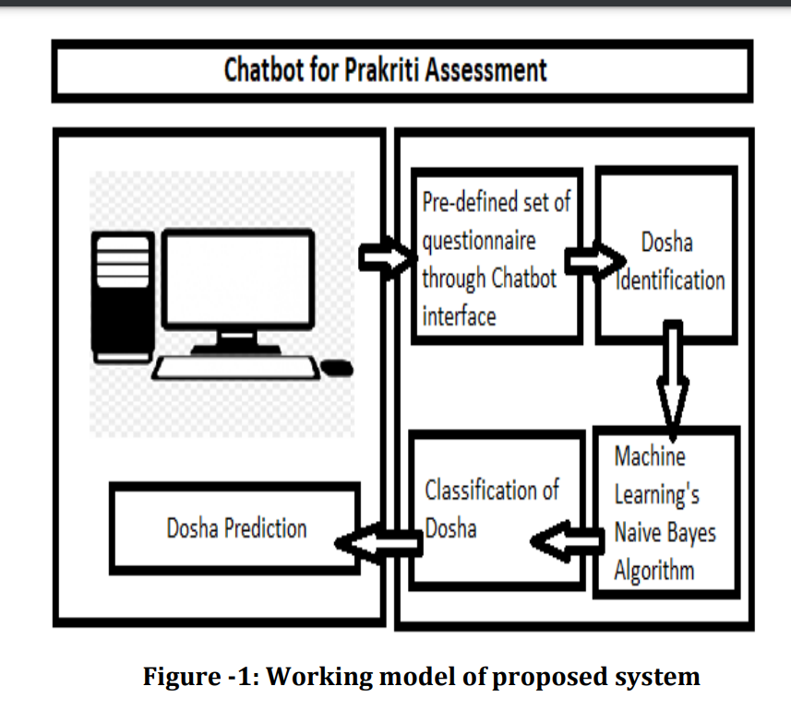

In this planned system, a chatbot is created to interact with users through a set of predefined questions to find out their individual Prakriti. By analyzing how users answer, the chatbot figures out the main Dosha. This system aims to understand a person's Dosha through their interactions and uses this info to give personalized advice. It's helpful for folks focused on their health. join by signing up on the website and answering preset questions. The Dosha prediction uses a Naive Bayes algorithm. An admin supervises the chatbot app, managing user details and data updates. The chatbot works based on a Prakriti dataset. Figure 1 shows how user answers are processed and predicted using an algorithm.

IMPLEMENTATION

• User Registration/Login:

Objective:

1. Allow users to create accounts or log in securely.

2. Ensure data privacy through authentication mechanisms.

Description:

1. Registration: Users can sign up for an account with a username, email, and password.

2. Login: Registered users access the app with their credentials.

3. Data Privacy: Ensure data privacy through authentication mechanisms.

• Chatbot Interaction:

Objective:

1. Engage users and gather information for Prakruti assessment.

2. Understand user responses accurately to determine Prakruti type.

Description:

1. Initiating Interactions: Chatbot starts conversations with users for assessment.

2. Clear Presentation: Chatbot asks questions clearly and understandably.

3. Interpreting Responses: Analyze user answers.

4. Determining Prakruti Type: Identify user's Prakruti type based on responses, provide feedback.

• Physical Traits Analysis:

Objective:

1.Collect user details about physical characteristics to figure out their dosha dominance and Prakruti type.

Description:

1. Users will input information like height, complexion, And hair type.

2. This helps the app determine which dosha(s) are most dominant for the user.

• Dosha Imbalance Assessment:

Objective:

1. Check if the doshas are balanced and provide advice to fix any imbalances Description:

1. Based on user input, the app will see if there are any imbalances in Vata, Pitta, or Kapha.

2. It then gives personalized tips to restore balance through lifestyle changes and diet.

• Dietary Guidance:

Objective:

1. Recommend foods based on Prakruti type to support health.

Description:

1. The app suggests what foods are best for each Prakruti type and which ones to avoid.

2. Recommendations are tailored to individual preferences and dietary needs.

• Exercise and Yoga Recommendations:

Objective: 1. Provide suitable exercises and yoga poses based on Prakruti type.

Description:

1. Users get personalized exercise and yoga suggestions to match their body type and dosha imbalances.

2. The app helps users stay fit and balanced physically and mentally.

• Living Well Tips:

Objective:

1. Offer advice on living healthier according to Ayurvedic principles.

Description: 1. Users receive tips on improving sleep, managing stress, self-care, and creating a healthy environment.

2. The app supports overall well-being by promoting Ayurvedic lifestyle practices.

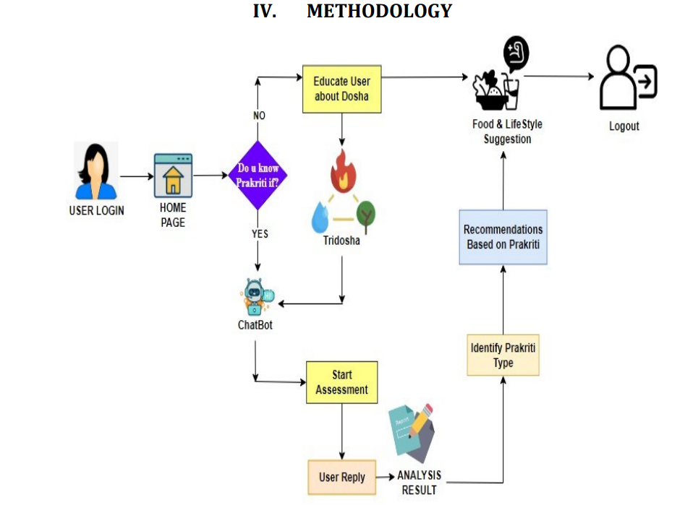

1. **CONCLUSION**

Our Prakriti chatbot VedaBuddy, which combines modern artificial intelligence with traditional Ayurvedic wisdom, is an example of how technology may be creatively applied to promote personal health and wellness. The chatbot breaks traditional limits by providing individualized guidance based on the age-old Ayurvedic principles, customized to each person's constitution, and available in several languages to serve a worldwide audience seeking holistic well-being.

The paper underscores the resurgence of ancient Ayurvedic wisdom facilitated by these chatbots, delivering personalized wellness guidance on a global scale. Through the utilization of dosha assessment methods and cutting-edge AI algorithms, these chatbots offer individualized health recommendations, engaging users in interactive dialogues that foster selfawareness and empowerment. In summary, the integration of Ayurvedic Prakriti chatbots signifies a promising path for personalized wellness, amalgamating ancient wisdom with modern technology to reshape healthcare practices significantly

1. **REFERENCES**
2. . Dabur's online prakriti test. [Last accessed on 2013 Mar 12]. Available from: <http://www.dabur.com/Ayurveda-Know%20your%20Prakriti-Prakriti%20Test> .
3. Ranade, M. (2024) Artificial intelligence in Ayurveda. Current concepts and prospects. Journal of Indian System of Medicine 12(1) 53-50.
4. Rastogi S. Development and Validation of a Prototype Prakriti Analysis Tool (PPAT): Inferences from a pilot study. *Ayu.*2010;33:209–18. [[PMC free article](https://www.ncbi.nlm.nih.gov/pmc/articles/PMC3611641/)] [[PubMed](https://pubmed.ncbi.nlm.nih.gov/23559792)] [[Google Scholar](https://scholar.google.com/scholar_lookup?journal=Ayu&title=Development+and+Validation+of+a+Prototype+Prakriti+Analysis+Tool+(PPAT):+Inferences+from+a+pilot+study&author=S+Rastogi&volume=33&publication_year=2010&pages=209-18&pmid=23559792&)]
5. Walkikar, S. S., & Rai, A (2023). Analysis of Prakriti in Ayurvedic Classical Texts. International Journal of Research in AYUSH and Pharmaceutical Sciences, 1-7.
6. <https://www.irjet.net/archives/V11/i2/IRJET-V11I277.pdf>
7. <https://www.ijfmr.com/papers/2024/2/17084.pdf>